**Java NetBeans 8.2 Application Development**

**Guidelines:**

* Create an application in Netbeans 8.2 (Java) utilizing GUI.

**Proposed Application Title:** MathSnap: Flashcard Drills

**Overview/Brief Description:**

**MathSnap: Flashcard Drills** is a mathematical flashcard that aims to help **toddlers aged 2 to 5** develop their mathematical skills. Users can choose which of the basic four mathematical operations (addition, subtraction, multiplication, and division) they like to answer and how difficult (easy: 1-digit numbers only, moderate: 1-digit and 2-digit numbers, hard: 2-digit numbers only) the problems will be. Upon launching the application, users are greeted with a simple "Start" button that transitions directly into the flashcard drill interface. Using the **flashcard gimmick**, random numbers will flash on the screen, and the user needs to input the answer. After entering the user's answer, immediate feedback of the correct answer will flash and show to the user after each given problem to support continuous learning.

**Application Flow:**

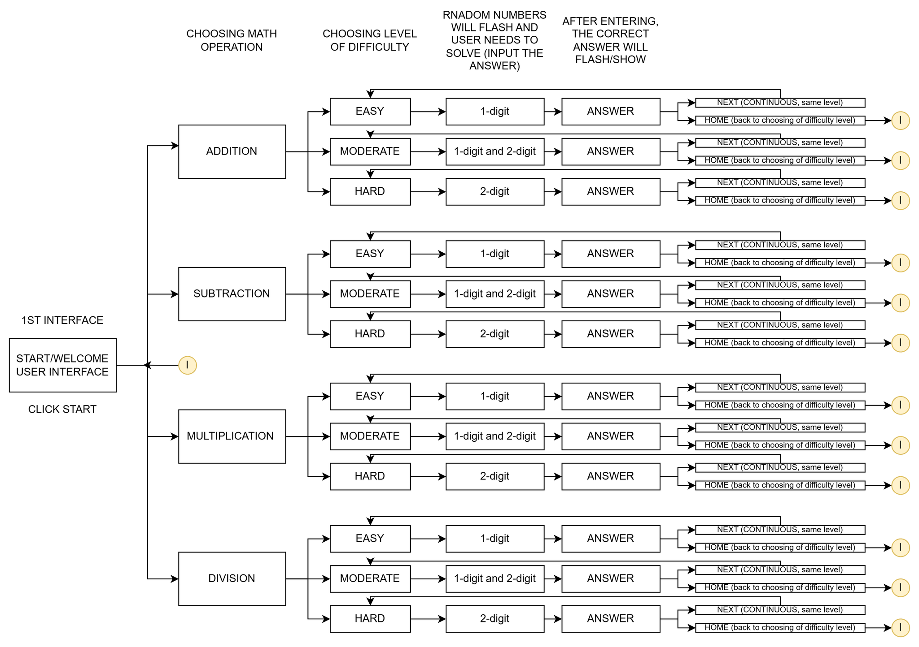

| **APPLICATION FLOW (USER INTERFACE)** | |
| --- | --- |
| 1ST | Welcome Screen of MathSnap: Flashcard Drill [Click to Start Button] |
| 2ND | Display the basic 4 Mathematical Operations [4 buttons to choose] |
| 3RD | Display the Numeral Problem (based on the chosen operation)  **Note:** Sa ilalim noon, may nakalagay na input box. Doon ilalagay ang sagot ng user and then click enter to submit the answer. Magrered/green yung outline ng input box kapag mali or tama and sagot. *(color effect)* |
| 4TH | After clicking the enter, lalabas yung tamang sagot *(flip effect)* and note kung correct “Nice/Awesome” or wrong “Try again.”  **Note:** With the same UI, may 2 options/buttons to go back ‘HOME’ or ‘NEXT’ (continuous; same level and same operation) |
| Continuous process siya. | |

**Notes/Remarks:**

* Netbeans 8.2
* May include ‘BACK’ button in every interface para may option si user to go back.
* GUI must be aligned with child-oriented button designs.
* Adjust font sizes and colors to maintain simplicity for young users.
* Implement feedback on whether the answers were correct after each drill.

**Suggested Color Palette:**

| Element | Color | Hex Code | Use For |
| --- | --- | --- | --- |
| Background | Light Sky Blue | #B3E5FC | Main background to keep it light and calm |
| Primary Buttons | Bright Yellow | #FFEB3B | “Start”, “Next”, “Try Again” buttons |
| Action Highlights | Soft Red | #EF5350 | Wrong answer feedback or cancel button |
| Correct Feedback | Lime Green | #8BC34A | Flash when the answer is correct |
| Text on Light BG | Deep Blue | #1A237E | Question/Answer text to keep it readable |
| Flashcard BG | White | #FFFFFF | Keeps math problems clean and simple |

